Appendix H

Granola Bars – Which One is Cool for School?

Learning Goal: apply your understanding of the Ontario Ministry of Education School Food and Beverage Policy to determine if a product is a “sell most”, “sell less”, or “not permitted for sale” food choice.

Nature Valley Sweet and Salty Nut Granola Bar

This product would be categorized as “___________________” because…

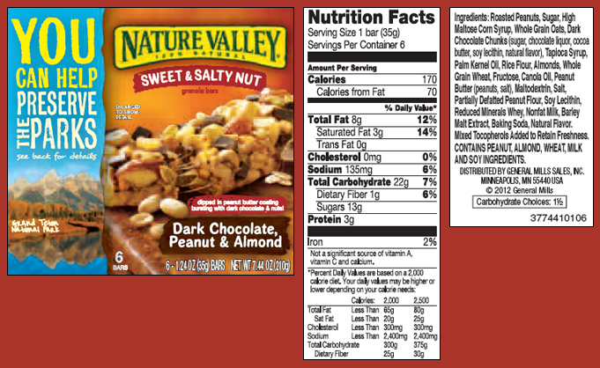

Quaker Chewy Granola Bar

This product would be categorized as “___________________” because…

GROUP – Grain Products
Sub-group | Sell Most (>80%) | Sell Less (<20%) | Not Permitted for Sale
 | Nutrition Criteria | Nutrition Criteria | Nutrition Criteria
Baked Goods | Fat: < 5 g  and Saturated fat: < 2 g  and Fibre: >2 g | Fat: < 10 g  and Saturated fat: < 2 g  and Sodium: > 2 g | Fat: > 10 g  or Saturated fat: > 2 g  or Sodium: < 2 g

