Grade 11: Personal Fitness Evaluation: Name: _________________________ /60 Marks
Using the following chart, list your work out including: the exercises, the muscles being used during the activity, the amount of weight lifted the number of reps & sets, and one alternate exercise that would work the same muscle group. You must complete a minimum of 5 exercises/ day. Completing aerobic activity is also an option. Make sure you balance your workout, working opposing muscle groups. Good luck with your workout. (25 Marks)
Day | Exercises | Muscles Being Worked | Weight | Reps | Sets | Alternative Exercises
Day | Exercises | Muscles Being Worked | Weight | Reps | Sets | Alternative Exercises

Part B: Diagrams (15): Using the terminology listed on the page, identify all the muscle on the diagram.
Pectoralis Major Latissimus Dorsi Trapezius Gastrocnemeus Bicep Brachii Tricep Brachii Deltoids Quadriceps Hamstrings Gluteals Rectus Femoris Forearm Flexors Forearm Extensors Sternocleidomastoid Tibialis Anterior
Part B Diagram:

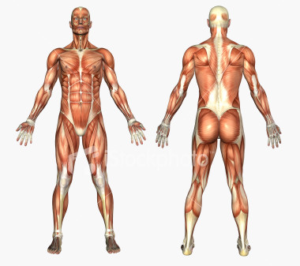
Part C: Healthy Living Articles (20 Marks)
Find an article that focuses on fitness, nutrition or lifestyle choices (ie. Obesity, personal training, steroid, eating disorders, smoking, etc.). You MUST include a copy of the original article. You may not use the same article as someone else in class. You should answer the following questions in paragraph form, therefore your answer MUST be composed of 3 paragraphs. You will earn 5 mark for each appropriate paragraph. (spelling, grammar, depth of discussion, etc) Paragraph 1: Summarize the article. Include at least 3 main points that were made. Paragraph 2: What is the significance of the article in terms of leading a healthy life? Paragraph 3: Give at least 3 examples that could be applied to your life.
Part C: PPL 4OI – Fitness Assignment Rubric
 | Level One | Level Two | Level Three | Level Four
Style and Organization  - Intro paragraph  - Paragraph organization  - Opinion paragraph  - Concluding paragraph  - Transition of ideas  - Focus and purpose of argument  / 16 | - Opening paragraph weakly introduces argument and does not adequately establish a thesis  - Limited organization of ideas and presented in brief / illogical paragraphs  - Opinion paragraph weak  - Little to no use of topic and transition sentences | - Opening paragraph introduces argument and establishes a thesis  - Sufficient organization of ideas and presented in paragraphs  - Simplistic opinion IP  - Some use of topic and transition sentences | - Opening paragraph introduces argument and establishes a clear thesis  - Effective organization of ideas presented in focused paragraphs  - Opinion well stated  - Good topic sentences and good transitions | - Opening paragraph skillfully introduces argument and establishes a strong thesis  - Highly effective organization of ideas developed into mature paragraphs  - Passionate opinion  - Excellent topic sentences and smooth transitions
Mechanics /4  - Spelling  - Grammar  - Sentence Structure | - Major spelling and grammatical errors  - Inconsistent and weak sentence structure | - Several major spelling and grammatical errors  - Adequate sentence structure | - A few spelling and grammatical errors  - Good sentence structure | - Nearly flawless spelling and grammar  - Excellent sentence structure
Comments:

