Birth Control Methods
Condom – 86 – 97% effective
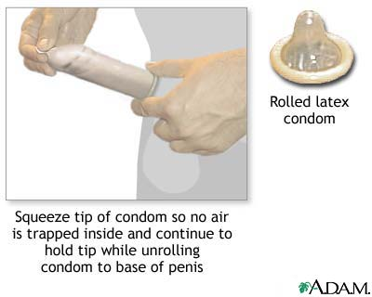
Cheap 75 cents each
How does it work? Catches the ______, aka blocks _________, prevents most STI’s
Six Steps to Proper Use 1._______________________________________________________2._______________________________________________________3._______________________________________________________4._______________________________________________________5._______________________________________________________
6.___________________________
Birth Control Pill (The Pill) – 92 -99.9% effective
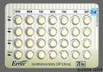
~ $20/month, prescribed by doctor, need a pap smear
___ STI protection
Can have _____effects such as – blood clots, nausea, mood changes and may interact with some drugs like antibiotics
How does it work? Prevents the monthly release of an egg, changing the lining of the uterus making implantation difficult and thickens the cervical mucus which hampers the movement of sperm.
How is it used? Taken ________, and must be take _______day at the _____ time
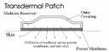
Transdermal Contraceptive Patch (The Patch) – 99.2-99.3% effective
How does it work? Same as The Pill
How is it used? Patch applied _____ a week on
the same day for ______ weeks in a row. During the fourth week, your period is expected to begin.

Vaginal Contraceptive Ring (Nuvo Ring) – 99% effective
Flexible, nearly transparent ring which releases hormones; convenient and discrete and doesn’t require daily attention
How does it work? Same as The Patch, and The Pill
How is it used? Ring is inserted into vagina where it remains for 3 weeks, followed by a 1 week ring-free interval.
Similar side effects as The Pill
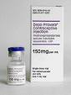
Depo-Provera Injection – 99.7% effective
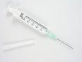
Prescription needed, no STI _______________
How does it work? Similar to The ______
How is it used? ___________ is given every 10-13 weeks by a health professional
Convenient, suitable for smokers
Side effects – some women experience disruption of menstrual patterns (i.e. irregular or no __________), headache, acne, n______________, breast tenderness, or ________ gain; delayed return of fertility; may lose significant bone mineral density
Female Condoms – 80-94%
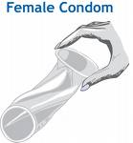
How does it work? Catches the semen
How is it used? Placed in ________ preventing _______ between the penis and vagina
Decreased risk of STI’s, can be used by women who smoke, no daily routine

Spermicides – 74-94% effective
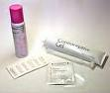
Ideal to be used in combination with a ____________
How does it work? It’s a chemical that ________ the sperm. Available as a film, jelly, suppository, cream, tablet, and foam.
How is it used? Placed in the __________ prior to genital contact
About $10/use, no STI protection
Contraceptive Sponge – 60-80% effective
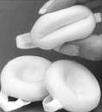
A intravaginal one size fits all barrier method which contains s__________
How does it work? Sponge absorbs and traps sperm. Spermicide kills sperms for a period of 12 hours.
How is it used? Inserted into the vagina before i_____________; must be left in for at least ___ hours after.
Small risk or TSS (toxic shock syndrome) if left in too long
Diaphragm and Spermicide – 80-94% effective
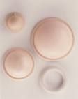
Latex dome with flexible rim which fits into the vagina to cover the c_________
How does it work? It’s a physical barrier between sperm and cervix; adding spermicide increases effectiveness
How does it work? Must be fitted properly by a health professional, and then can be used by woman up to ___ hours before intercourse
Offers _______ STI protection, can be awkward to use

Intrauterine Device (IUD) – 98.5% effective
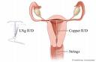
Small plastic “T” shaped device wrapped with copper wire
How does it work? Ovulation not affected; it changes the uterine lining, thus p___________ fertilization and/or i________________
How is it used? Inserted by a health professional; different brands last from between 30 months to 5 years (60 months)
Don’t have to remember birth control; no STI protection

Sterilization – 99.5% effective
Tubal Ligation Vasectomy
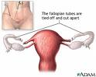
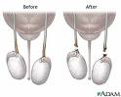
No STI protection
Cost is covered by OHIP
$2000 female, $500 male
Mostly irreversible
Surgery
In females, woman is put to sleep, 6 week recovery In males, local freezing only, 24 hour recovery
F__________ tubes are blocked to prevent sperm Blocks the tubes which prevents sperms from and egg from uniting entering the semen
Emergency Contraceptive Pill (Morning After Pill) – Not to be used as a method of birth control
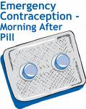
Only for emergencies
Can be used within _____ hours of unprotected intercourse, or contraceptive failure
It can significantly decrease the chance of pregnancy, by either preventing ovulation or changing the lining of the uterus so implantation is impossible.
A prescription can be obtained at Family Physicians, Urgent Health Care Clinics, city Sexual Health programs, and over the counter at some pharmacies.
Side effects include:
Nausea, vomiting, headaches, breast tenderness, dizziness, fluid retention and irregular bleeding
Danger signs include:
- Abdominal pains (severe)
- Chest pain or shortness of breath
- Headaches (severe)
- Eye problems, such as blurred vision
- Severe leg or arm pain or numbness
Go directly to clinic, or the emergency room at your local hospital

