Appendix E-1 Name: __________________________

Food Labels & Health Information Claims (11 marks)

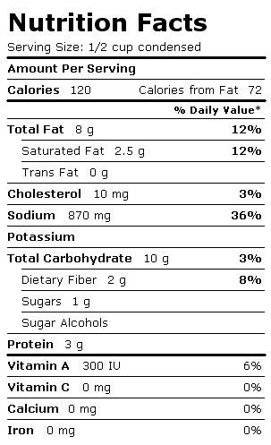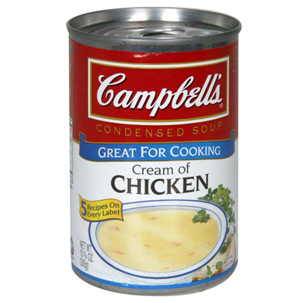

- What is the serving size?
- How many calories are in one serving?
- How many grams of fat are in one serving?
- Highlight one nutrient on the Nutrient Facts table that is important to you. What is the % Daily Value for this nutrient?
- Decide if you want to get less or more of the nutrient you have highlighted.
____ less of this nutrient
____more of this nutrient
- Is this food a good choice for you?
____Yes. Why? ___________________________________________
____No Why? ___________________________________________

7. Nutritional claims on labels follow trends. The popularity of foods containing omega-3 polyunsaturated fatty acids and the no trans fat craze has hit every label eligible. Take for example the following strawberry yogurt food label.

STRAWBERRY YOGURT
- Source of Omega-3 Polyunsaturates
- Low in saturated fat
- Free of trans fat
- Low in cholesterol
- Source of calcium
- Vitamins B2 and B12

Ingredients: modified milk ingredients, strawberries, sugar, modified corn starch, carrageenan, pectin, flax oil, natural flavour, rosemary extract, lemon juice concentrate, colour, active bacterial cultures.
Nutrition Information
(per 113 g Serving)
Energy - cal | 100 cal
Protein | 3.0 g
Carbohydrate | 19 g
Sugars | 14 g
Fibre | 0 g
Fat | 1.5 g
Saturated  Trans | 0.5 g  0 g
Polyunsaturated  Omega-6  Omega-3 | 0.4 g  0.1 g  0.3 g
Monounsaturated | 0.3 g
Cholesterol | 5 mg
Percentage of Recommended Daily Intake (per 113 g Serving)
Vitamin A | 0 %
Vitamin C | 0 %
Calcium | 10 %
Iron | 0 %
Riboflavin B2 | 15 %
Vitamin B12 | 15 %

a) What is the significance of a diet that contains the omega-3 polyunsaturated fatty acids? (1 mark)
b) Why is it important to eliminate foods that contain trans fats from your diet? (1 mark)
c) Examine the yogurt label carefully. This label lists six benefits, but what do you think is the major downfall of this product? (1 mark)

8. Examine the information found in the Health Canada website regarding food label regulations. The food label below represents realistic information. What special nutrient-related health claims could the manufacturer of this product make?
(2 marks)

CEREAL
Ingredients: Whole Wheat, Wheat Bran, Sugar, Salt, Malt, Thiamin, Pyridoxine Hydrochloride, Folic Acid, Reduced Iron, BHT.
Nutrition Information
(per 30g Serving Cereal 175 mL, 3/4 cup)
Energy - cal |  | 100 cal
Energy - kj |  | 420 kj
Protein |  | 3.0 g
Fat |  | 0.6 g
Carbohydrate |  | 24 g
Sugars |  | 4.4 g
Starch |  | 16.6 g
Dietary fibre |  | 3.0 g
Sodium |  | 265 mg
Potassium |  | 168 mg
Percentage of Recommended Daily Intake
(per 30g Serving Cereal 175 mL, 3/4 cup)
Thiamin | 46 %
Niacin | 6 %
Vitamin B6 | 10 %
Folacin | 8 %
Iron | 28 %

